# EXP NO: 09 Cold System Forensics NAME : ADHIYAN PERIYAR R P

# DATE: 04/09/2025 ROLL NO : 231901002

**AIM:**

A look into the concepts of cold system forensics and how DFIR teams examine offline systems.

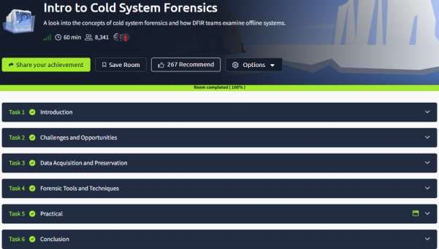

# Task 1 : Introduction



# Task 2 : Challenges and Opportunities

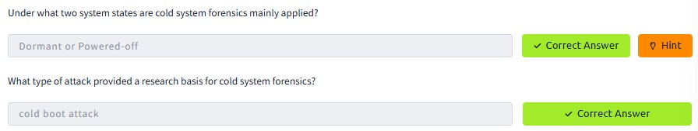

# Task 3 : Data Acquisition and Preservation

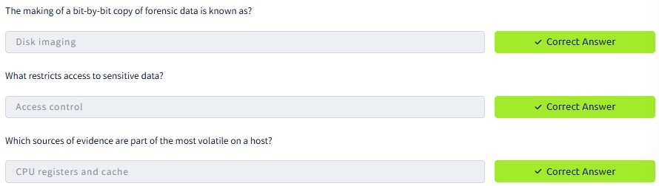

# Task 4 : Forensic Tools and Techniques

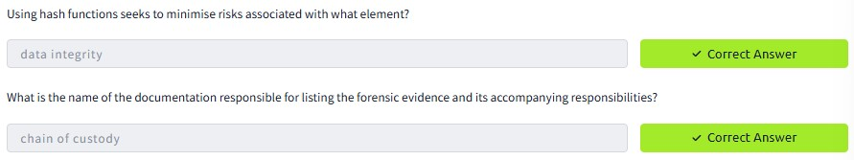

# Task 5 : Practical

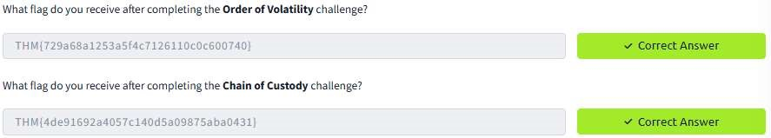

**RESULT :**

Cold System Forensics is successfully completed in tryhackme platform.